Font Family details of the DSCIS application

1. Application Banner:

Tahoma, sans-serif ( provides MonoSpacing for Session timer)

1. Application Section:
   1. HelvNeueLightforIBM, Helvetica, Arial
   2. HelvNeueMediumforIBM, Helvetica, Arial
   3. HelvNeueRomanforIBM, Helvetica, Arial
   4. HelvNeueBoldforIBM, Helvetica, Arial

Full screen

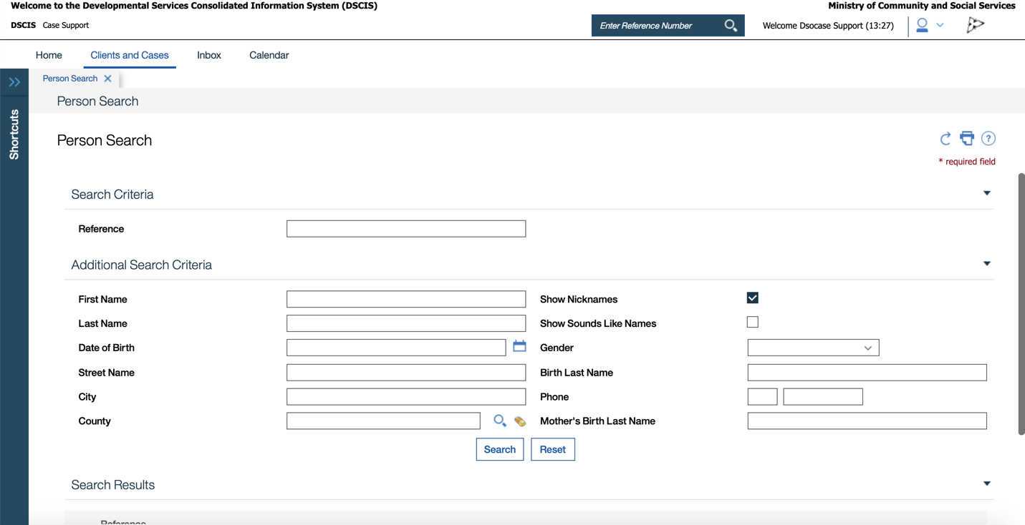

1. Application Banner Fonts : Tahoma, sans-serif

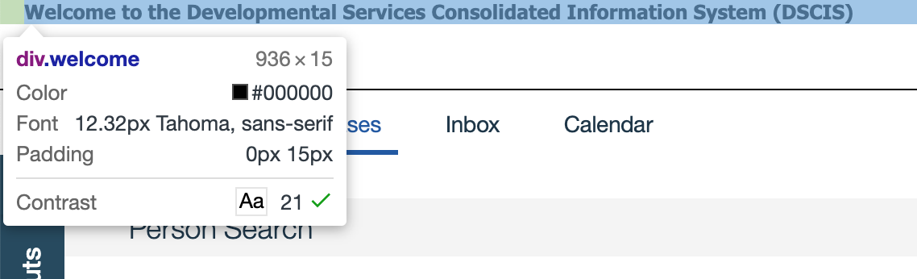

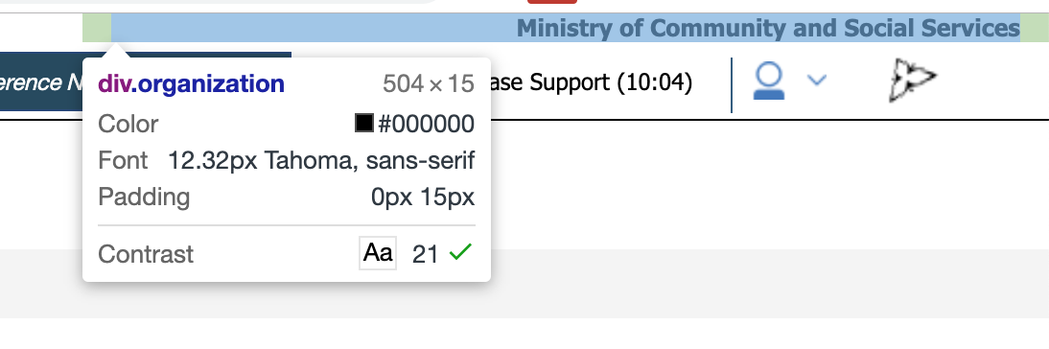

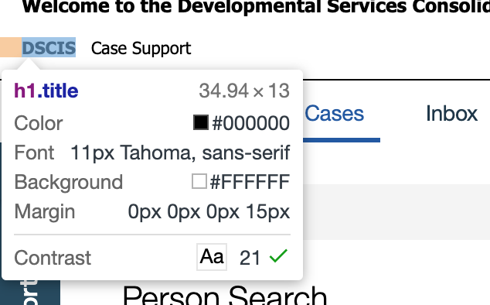

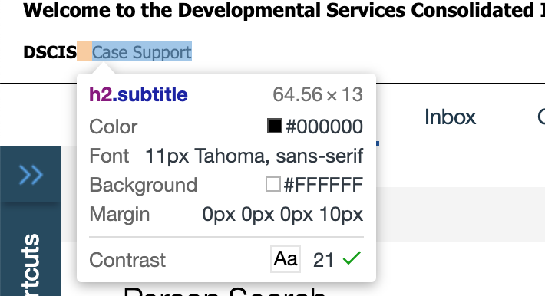

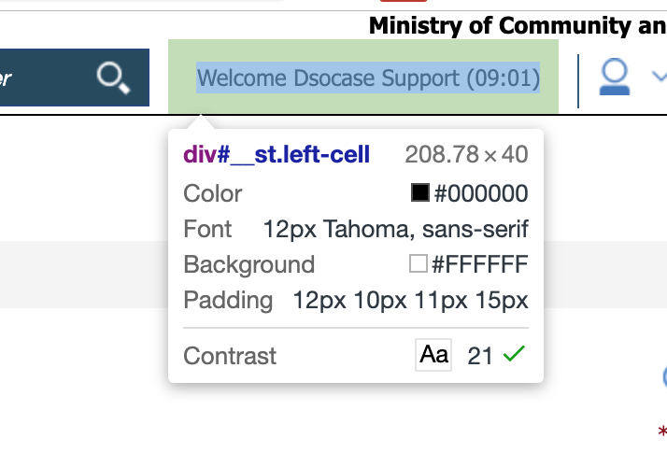

1. Application Sections

